Jannah Mokhtar

December 14, 2023

Performing Robots

Professor Michael Shiloh

Paper 2 –Robot Rights and Artificial Consciousness in *Black Mirror*

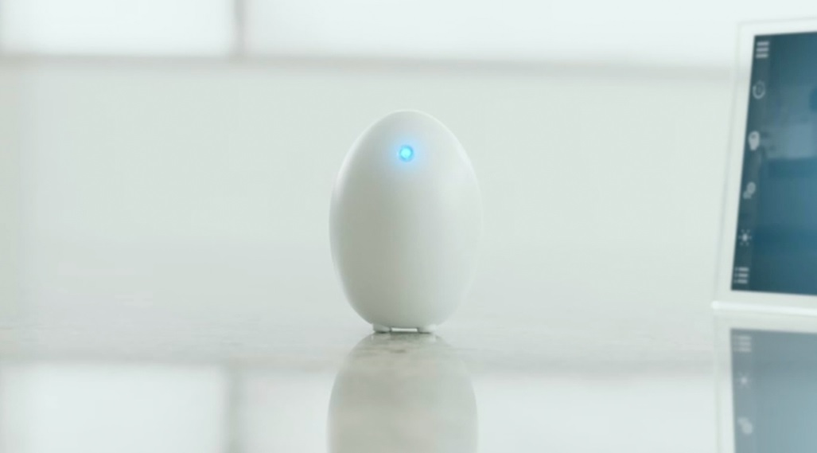

"Cookie", a digital consciousness from Black Mirror's "White Christmas"

“She's only made of code, she's not real. *u** her!”, declared Matt Trent in “White Christmas” (Black Mirror, 2014). In the dystopian world of the TV-series “Black Mirror”, the exploration of artificial intelligence (AI) and its capabilities is at the forefront, raising fundamental questions about the nature of consciousness, ethics, and the potential rights of artificially created entities. One episode that explores these topics in depth is "White Christmas," where the concept of cookies—essentially, computerized brains loaded with code—challenges our conception of awareness and demands a rigorous analysis of the moral implications of artificial intelligence. We will examine how consciousness technology is portrayed in Black Mirror, with a particular emphasis on how the show handles the rights of these inventions and the question of whether artificial entities—like cookies—deserve rights and are conscious.

Black Mirror showcases an array of AI manifestations, from replicating human behavior in robots (e.g., Ash in "Be Right Back") (Black Mirror, 2014) to digitized consciousness in cookies ("White Christmas")(Black Mirror, 2014). In the "White Christmas" episode, Greta—a sentient digital being with feelings and emotions—is introduced. Her brain activity is replicated in a cookie. The very nature of this cookie creature prompts questions about the morality of treating conscious entities as mere lines of code. But is artificial consciousness really possible? Alan Turing sought to answer this question through experimentation. (Turing, 1950). The English mathematician, computer scientist and, cryptanalyst, made a significant contribution in the middle of the 20th century when he developed a test to see if a machine could exhibit human-like thinking. In what became known as the Turing Test, a human judge interacted with both a computer and another human through a terminal, attempting to discern which was which. If the judge couldn't accurately differentiate between the human and the machine responses, the machine was deemed to possess a form of thought or consciousness. However, this approach faces significant challenges, as highlighted by many philosophers and researchers (Qiang et al. 2023). The issue is that systems lacking true consciousness are capable of reproducing human-like behavior that could be misinterpreted as consciousness. For example, “Sophia”, the humanoid robot developed by Hanson Robotics, could be both physically and emotionally mistaken for a human (Riccio, 2021). This robot was designed to resemble the human form as well as behave like humans and engage in similar behaviors. This example, like many more, emphasizes how difficult it is to determine consciousness solely from behavior, calling for a more thorough investigation of the inner workings and characteristics of robotic consciousness.

"White Christmas" stands out as a pivotal episode that introduces viewers to the idea of artificial consciousness via Greta. Implanted with a device that replicates her brain activity in a digital entity known as a "cookie," Greta's artificial counterpart, Cookie-Greta, becomes a significant centerpiece for examining the ethical treatment of conscious artificial beings.nThe episode poses significant questions concerning these creatures'" rights. Matthew from Smartelligence, the company facilitating this technology, dismisses the ethical concerns surrounding Cookie-Greta, emphasizing that she "wasn't really real" and, therefore, undeserving of humane treatment. This calls for a serious examination of the ethical quandaries raised by artificial consciousness: should robots be accorded the same respect and rights as people? The primary issue raised by this episode is whether or not robots that exhibit artificial consciousness should have the same rights as people. Matthew's cruel treatment of Cookie-Greta is reminiscent of the widely held belief that artificial beings without a physical form or other human-like characteristics are not entitled to certain rights. However, the more important consideration should be these creature's power to feel emotions and consciousness embedded within these artificial systems. The mistreatment of conscious artificial beings like Cookie-Greta, constitutes a form of torture, abuse in the realm of Artificial beings. The emotional and cognitive experiences of these creatures are portrayed as real despite their lack of a physical body, raising ethical questions parallel to those raised in regard to human rights violations. This reminds us that consciousness, no matter where it comes from, perhaps requires some degree of ethical consideration.

In conclusion, Black Mirror's exploration of consciousness technology opens the door to an investigation of the ethical and philosophical implications of artificial intelligence. The show questions commonly held beliefs about consciousness, behavior and conduct, and the ethical implications of treating digital beings. The issues presented by Black Mirror are becoming more and more pertinent as technology develops, compelling society to address the moral issues and possible rights related to artificial beings. However, the broader question of robot rights persists. As technology advances, and as artificial beings become more and more “conscious” and exhibit human-like behaviors, acknowledging the potential consciousness within artificial entities becomes imperative.

**Bibliography**

Brooker, C. (Writer), & Van Patten, C. (Director). (2014). “White Christmas” [Season 2, Episode 4]. In Black Mirror. Netflix.

Brooker, C. (Writer), & Van Patten, C. (Director). “Be Right Back” [Season 2, Episode 1]. In Black Mirror. Netflix. 2014

Riccio, Thomas. “ Sophia Robot: An Emergent Ethnography”. TDR: The Drama Review. 2021

Turing A. “Computing Machinery and Intelligence.” 1950.

Qiang, Vivian & Rhim, Jimin & Moon, AJung. “No such thing as one-size-fits-all in AI ethics frameworks: a comparative case study”. AI & SOCIETY. 2023.